Mario Mujica
CIST 2500
Semester Project

Narrative

For this CIST 2500 Semester Project, I’ve decided to choose Option Two: Learning How to Use R or Jupyter Notebook for Statistics. My major is computer science with a concentration in software engineering. However, I am a post-baccalaureate student attempting to obtain my second bachelor’s degree. This is my first semester taking computer science courses. Therefore, I only have some experience with Python, but I’m enjoying it so far. For these reasons, I want to expand my beginner skills by teaching myself how to use platforms and scripting languages for statistical analysis. This would help me in getting started with understanding data science. Overall, I believe this option for the project would help me in becoming a better software developer.
I have successfully installed a working copy of Python and it appears to be functioning as expected. The next preliminary task I need to complete is reading through the tutorial that was provided called, How to Use Jupyter Notebook: A Beginner’s Tutorial, by Dataquest. This will help me understand how to navigate and use the platform for data science. For this project, I will need to perform similar tests as the ones done in various chapters. Therefore, I would also need to review all previous relevant Practice Portfolios. I will be using the same datasets from these practice problems.
The following goal would be to conduct the statistical tests, similar to the applicable chapters, on Jupyter Notebook. So far, I have a good understanding on the Practice Portfolios for Chapter 2 and 3 (descriptive statistics: tabular and graphical displays, and numerical measures). After going through the tutorial, I will begin with Chapter 2. I will follow along with upcoming chapters by starting to work on similar tests to the ones done in class.

Statistical Tests

For my project submission, I attached a pdf file containing all the procedures, blocks of code, and results of my analysis methods. In this document I have provided a few pictures below.

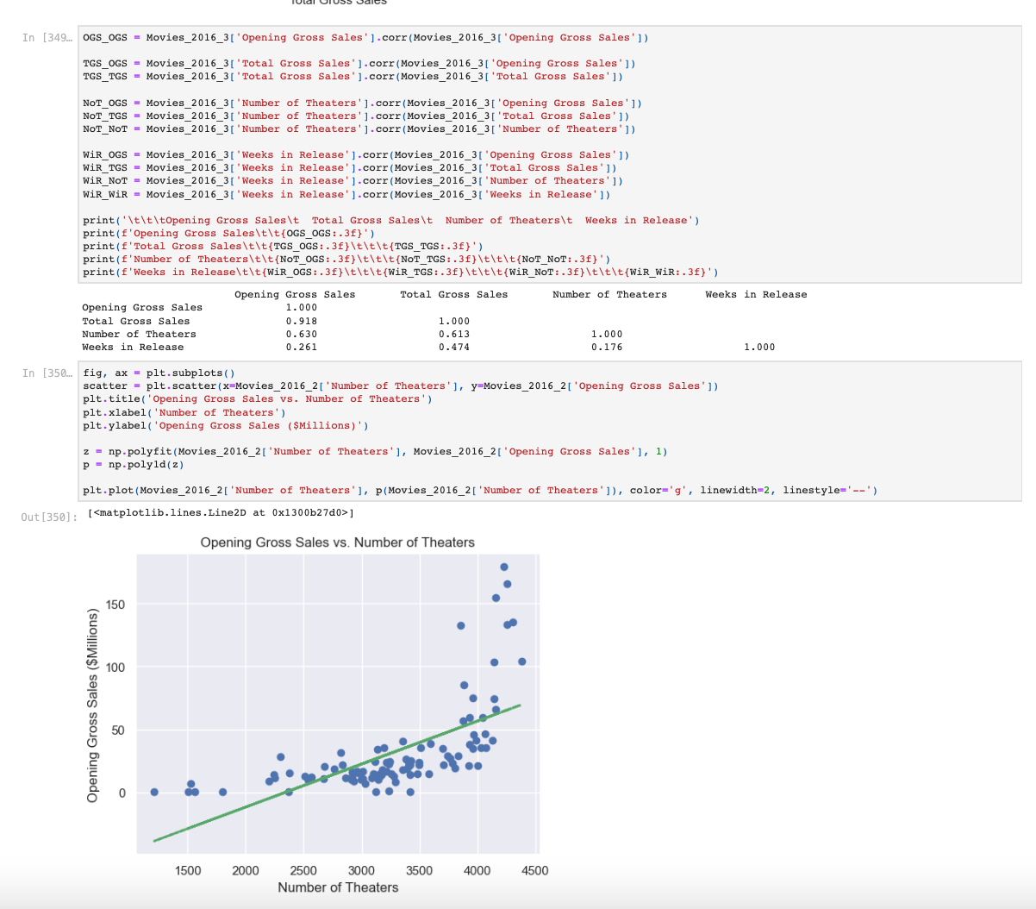

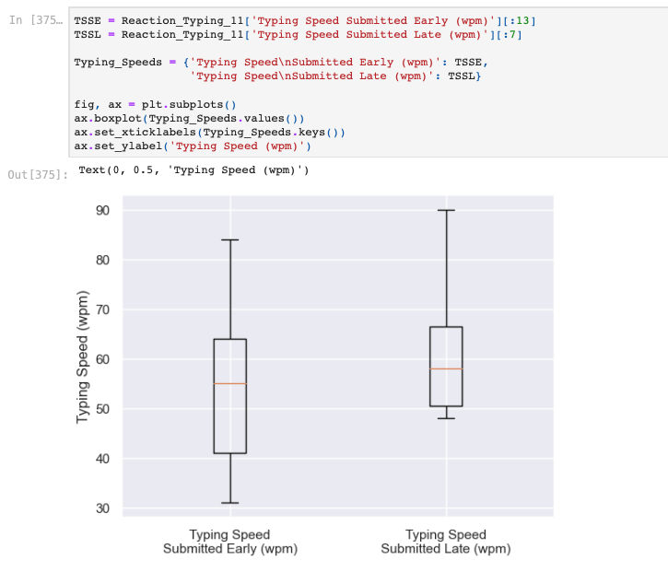

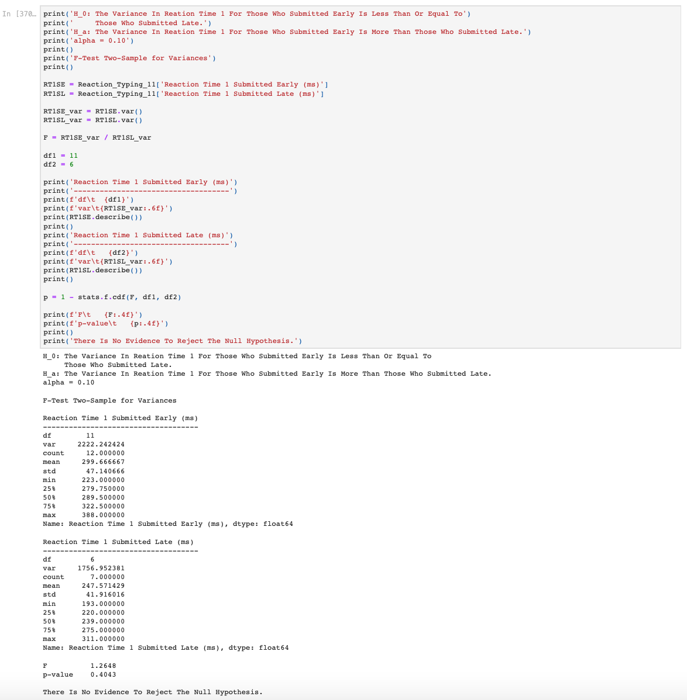

Summary & Reflection

I conducted a large amount of research to find packages that would make my results and graphs look as close to the Practice Portfolios done in Microsoft Excel. However, there were still differences I was unable to translate well to Python. The methods for adjusting how tables, graphs, and results look like are far better and intuitive in Microsoft Excel. Excel seems to thrive in making statistical analysis look visually appealing. With that said, I believe Python has many uses that could be applied to the real world. I had a difficult time in learning how to perform similar statistics in Python. I am new to the world of coding. However, this project really pushed me to try my best and test my limits. The knowledge I learned is tremendous, and I hope to continue to build on it.

